Server/test-course.js
const Course = require("./models/Course");

const runTest = async () => {
console.log("=== COURSE MODEL TEST ===");

const validCourse = new Course({
code: "ite999",
title: "Test Course",
credits: 4,
description: "Course used for testing",
prerequisites: ["CSC101"]
});

try {
await validCourse.validate();

console.log("PASS - Valid course accepted");
console.log(validCourse);

if (validCourse.code === "ITE999") {
console.log("PASS - Course code converted to uppercase");
} else {
console.log("FAIL - Course code uppercase");
}

if (Array.isArray(validCourse.prerequisites)) {
console.log("PASS - prerequisites is an array");
}
} catch (error) {
console.log("FAIL - Valid course rejected");
console.log(error.message);
}

const missingCode = new Course({
title: "Missing Code"
});

try {
await missingCode.validate();
console.log("FAIL - Course without code accepted");
} catch (error) {
console.log("PASS - Course without code rejected");
}

const missingTitle = new Course({
code: "TEST100"
});

try {
await missingTitle.validate();
console.log("FAIL - Course without title accepted");
} catch (error) {
console.log("PASS - Course without title rejected");
}

console.log("=== COURSE TEST COMPLETE ===");
};

runTest();

Result
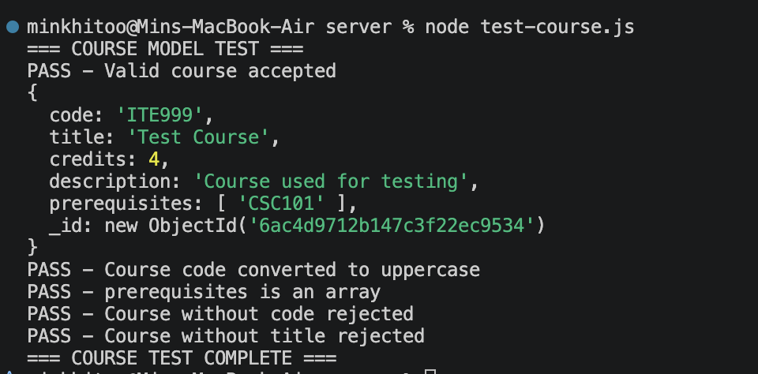
server/test-user.js
const User = require("./models/User");

const runTest = async () => {
console.log("=== USER MODEL TEST ===");

const student = new User({
name: "Test Student",
email: "TEST@UNIVERSITY.COM",
passwordHash: "hashedpassword",
role: "student",
studentId: "TEST001"
});

try {
await student.validate();

console.log("PASS - Valid student accepted");

if (student.email === "test@university.com") {
console.log("PASS - Email converted to lowercase");
}

if (student.active === true) {
console.log("PASS - active defaults to true");
}

if (student.advisorId === null) {
console.log("PASS - advisorId defaults to null");
}
} catch (error) {
console.log("FAIL - Valid student rejected");
console.log(error.message);
}

const missingStudentId = new User({
name: "Student Two",
email: "student2@test.com",
passwordHash: "hash",
role: "student"
});

try {
await missingStudentId.validate();
console.log("FAIL - Student without studentId accepted");
} catch (error) {
console.log("PASS - Student without studentId rejected");
}

const advisor = new User({
name: "Test Advisor",
email: "advisor@test.com",
passwordHash: "hash",
role: "advisor"
});

try {
await advisor.validate();
console.log("PASS - Advisor can omit studentId");
} catch (error) {
console.log("FAIL - Advisor rejected");
}

const invalidRole = new User({
name: "Invalid User",
email: "invalid@test.com",
passwordHash: "hash",
role: "teacher"
});

try {
await invalidRole.validate();
console.log("FAIL - Invalid role accepted");
} catch (error) {
console.log("PASS - Invalid role rejected");
}

console.log("=== USER TEST COMPLETE ===");
};

runTest();

Result
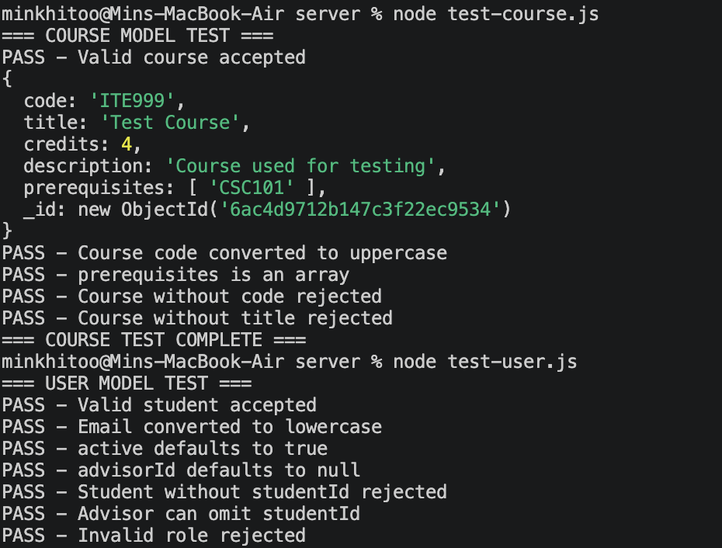
server/test-offering.js
const mongoose = require("mongoose");
const Offering = require("./models/Offering");

const runTest = async () => {
console.log("=== OFFERING MODEL TEST ===");

const offering = new Offering({
courseId: new mongoose.Types.ObjectId(),
term: "2026-1",
section: "A",
instructor: "Dr. Test",
day: "Monday",
startTime: "08:30",
endTime: "10:30",
room: "A101",
seats: 30
});

try {
await offering.validate();

console.log("PASS - Valid offering accepted");

if (offering.seatsTaken === 0) {
console.log("PASS - seatsTaken defaults to 0");
}

if (offering.addDropOpen === false) {
console.log("PASS - addDropOpen defaults to false");
}

if (offering.addDropCloseDate === null) {
console.log("PASS - addDropCloseDate defaults to null");
}
} catch (error) {
console.log("FAIL - Valid offering rejected");
console.log(error.message);
}

const zeroSeats = new Offering({
courseId: new mongoose.Types.ObjectId(),
term: "2026-1",
section: "B",
instructor: "Dr. Test",
day: "Tuesday",
startTime: "10:30",
endTime: "12:30",
room: "B101",
seats: 0
});

try {
await zeroSeats.validate();
console.log("FAIL - 0 seats accepted");
} catch (error) {
console.log("PASS - 0 seats rejected");
}

const negativeTaken = new Offering({
courseId: new mongoose.Types.ObjectId(),
term: "2026-1",
section: "C",
instructor: "Dr. Test",
day: "Wednesday",
startTime: "10:30",
endTime: "12:30",
room: "C101",
seats: 30,
seatsTaken: -1
});

try {
await negativeTaken.validate();
console.log("FAIL - Negative seatsTaken accepted");
} catch (error) {
console.log("PASS - Negative seatsTaken rejected");
}

console.log("Required fields:");

console.log(
"seats:",
Boolean(Offering.schema.path("seats"))
);

console.log(
"seatsTaken:",
Boolean(Offering.schema.path("seatsTaken"))
);

console.log(
"addDropOpen:",
Boolean(Offering.schema.path("addDropOpen"))
);

console.log(
"addDropCloseDate:",
Boolean(Offering.schema.path("addDropCloseDate"))
);

console.log("=== OFFERING TEST COMPLETE ===");
};

runTest();
Result
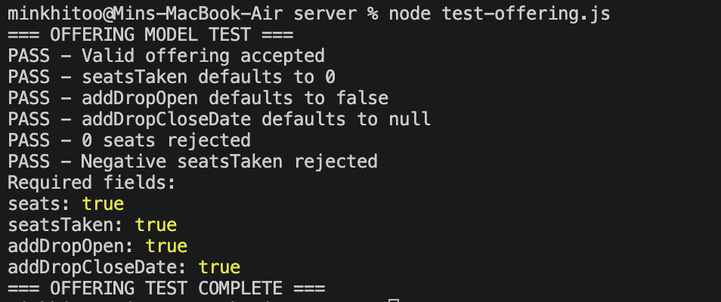
server/test-registration.js
const mongoose = require("mongoose");
const Registration = require("./models/Registration");

const runTest = async () => {
console.log("=== REGISTRATION MODEL TEST ===");

const registration = new Registration({
studentId: new mongoose.Types.ObjectId(),
offeringId: new mongoose.Types.ObjectId(),
term: "2026-1"
});

try {
await registration.validate();

console.log("PASS - Valid registration accepted");

if (registration.status === "registered") {
console.log("PASS - status defaults to registered");
}

if (registration.createdAt instanceof Date) {
console.log("PASS - createdAt generated automatically");
}
} catch (error) {
console.log("FAIL - Valid registration rejected");
console.log(error.message);
}

const dropped = new Registration({
studentId: new mongoose.Types.ObjectId(),
offeringId: new mongoose.Types.ObjectId(),
term: "2026-1",
status: "dropped"
});

try {
await dropped.validate();
console.log("PASS - dropped status accepted");
} catch (error) {
console.log("FAIL - dropped status rejected");
}

const invalidStatus = new Registration({
studentId: new mongoose.Types.ObjectId(),
offeringId: new mongoose.Types.ObjectId(),
term: "2026-1",
status: "pending"
});

try {
await invalidStatus.validate();
console.log("FAIL - Invalid pending status accepted");
} catch (error) {
console.log("PASS - Invalid pending status rejected");
}

const missingStudent = new Registration({
offeringId: new mongoose.Types.ObjectId(),
term: "2026-1"
});

try {
await missingStudent.validate();
console.log("FAIL - Missing studentId accepted");
} catch (error) {
console.log("PASS - Missing studentId rejected");
}

console.log(
"Indexes:",
Registration.schema.indexes()
);

console.log("=== REGISTRATION TEST COMPLETE ===");
};

runTest();
Result
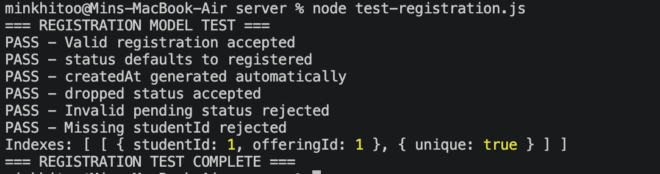
server/test-record.js
const mongoose = require("mongoose");
const Record = require("./models/Record");

const runTest = async () => {
console.log("=== RECORD MODEL TEST ===");

const validRecord = new Record({
studentId: new mongoose.Types.ObjectId(),
courseId: new mongoose.Types.ObjectId(),
term: "2025-2",
grade: "B+"
});

try {
await validRecord.validate();
console.log("PASS - Valid record accepted");
} catch (error) {
console.log("FAIL - Valid record rejected");
console.log(error.message);
}

const failedRecord = new Record({
studentId: new mongoose.Types.ObjectId(),
courseId: new mongoose.Types.ObjectId(),
term: "2025-2",
grade: "F"
});

try {
await failedRecord.validate();
console.log("PASS - F grade accepted");
} catch (error) {
console.log("FAIL - F grade rejected");
}

const withdrawnRecord = new Record({
studentId: new mongoose.Types.ObjectId(),
courseId: new mongoose.Types.ObjectId(),
term: "2025-2",
grade: "W"
});

try {
await withdrawnRecord.validate();
console.log("PASS - W grade accepted");
} catch (error) {
console.log("FAIL - W grade rejected");
}

const invalidGrade = new Record({
studentId: new mongoose.Types.ObjectId(),
courseId: new mongoose.Types.ObjectId(),
term: "2025-2",
grade: "A+"
});

try {
await invalidGrade.validate();
console.log("FAIL - Invalid A+ grade accepted");
} catch (error) {
console.log("PASS - Invalid A+ grade rejected");
}

const missingCourse = new Record({
studentId: new mongoose.Types.ObjectId(),
term: "2025-2",
grade: "A"
});

try {
await missingCourse.validate();
console.log("FAIL - Record without courseId accepted");
} catch (error) {
console.log("PASS - Record without courseId rejected");
}

console.log(
"Indexes:",
Record.schema.indexes()
);

console.log("=== RECORD TEST COMPLETE ===");
};

runTest();
Result
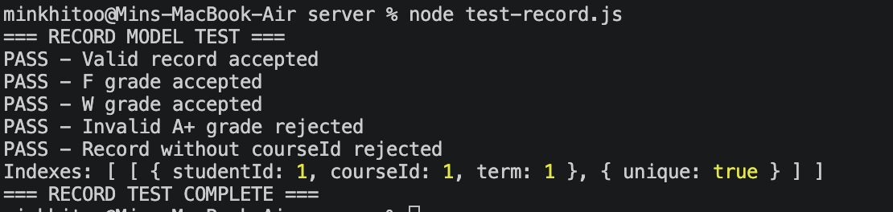
server/test-notification.js
const mongoose = require("mongoose");
const Notification = require("./models/Notification");

const runTest = async () => {
console.log("=== NOTIFICATION MODEL TEST ===");

const registeredNotification =
new Notification({
userId: new mongoose.Types.ObjectId(),
type: "course_registered",
message: "You were registered for ITE220."
});

try {
await registeredNotification.validate();

console.log(
"PASS - course_registered notification accepted"
);

if (registeredNotification.read === false) {
console.log(
"PASS - read defaults to false"
);
}
} catch (error) {
console.log(
"FAIL - Valid notification rejected"
);
console.log(error.message);
}

const droppedNotification =
new Notification({
userId: new mongoose.Types.ObjectId(),
type: "course_dropped",
message: "ITE220 was dropped."
});

try {
await droppedNotification.validate();

console.log(
"PASS - course_dropped notification accepted"
);
} catch (error) {
console.log(
"FAIL - course_dropped notification rejected"
);
}

const invalidNotification =
new Notification({
userId: new mongoose.Types.ObjectId(),
type: "course_updated",
message: "Invalid type"
});

try {
await invalidNotification.validate();

console.log(
"FAIL - Invalid notification type accepted"
);
} catch (error) {
console.log(
"PASS - Invalid notification type rejected"
);
}

const missingMessage =
new Notification({
userId: new mongoose.Types.ObjectId(),
type: "course_registered"
});

try {
await missingMessage.validate();

console.log(
"FAIL - Missing message accepted"
);
} catch (error) {
console.log(
"PASS - Missing message rejected"
);
}

if (
Notification.schema.options.timestamps === true
) {
console.log(
"PASS - timestamps are enabled"
);
} else {
console.log(
"FAIL - timestamps are not enabled"
);
}

console.log(
"=== NOTIFICATION TEST COMPLETE ==="
);
};

runTest();
Result
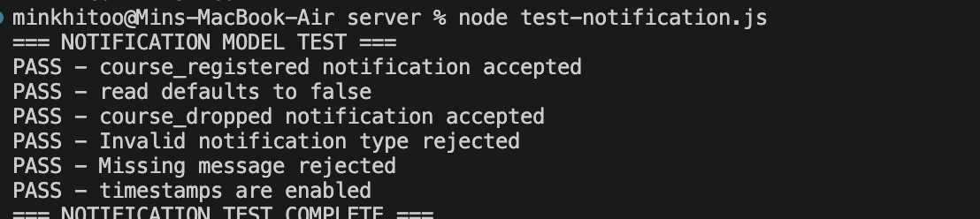
server/test-seed.js
const mongoose = require("mongoose");
require("dotenv").config();

const User = require("./models/User");
const Course = require("./models/Course");
const Offering = require("./models/Offering");
const Registration = require("./models/Registration");
const Record = require("./models/Record");

const PASSING_GRADES = [
"A",
"B+",
"B",
"C+",
"C",
"D+",
"D"
];

const runTest = async () => {
try {
console.log("=== SEED DATA TEST ===");

await mongoose.connect(
process.env.MONGO_URI
);

console.log("MongoDB connected");

const students =
await User.countDocuments({
role: "student"
});

const advisors =
await User.countDocuments({
role: "advisor"
});

const admins =
await User.countDocuments({
role: "admin"
});

const courses =
await Course.countDocuments({});

const offerings =
await Offering.countDocuments({
term: "2026-1"
});

const records =
await Record.countDocuments({});

console.log(
students === 25
? "PASS - 25 students"
: `FAIL - Students: ${students}`
);

console.log(
advisors === 4
? "PASS - 4 advisors"
: `FAIL - Advisors: ${advisors}`
);

console.log(
admins === 1
? "PASS - 1 admin"
: `FAIL - Admins: ${admins}`
);

console.log(
courses === 18
? "PASS - 18 courses"
: `FAIL - Courses: ${courses}`
);

console.log(
offerings === 26
? "PASS - 26 sections"
: `FAIL - Sections: ${offerings}`
);

console.log(
records === 312
? "PASS - 312 academic records"
: `FAIL - Records: ${records}`
);

// F TEST

const fRecord =
await Record.findOne({
grade: "F"
});

console.log(
fRecord
? "PASS - At least one F exists"
: "FAIL - No F record"
);

// W TEST

const wRecord =
await Record.findOne({
grade: "W"
});

console.log(
wRecord
? "PASS - At least one W exists"
: "FAIL - No W record"
);

// FULL SECTION TEST

const fullSection =
await Offering.findOne({
$expr: {
$gte: [
"$seatsTaken",
"$seats"
]
}
});

console.log(
fullSection
? "PASS - At least one full section exists"
: "FAIL - No full section"
);

// ALREADY PASSED TEST

const currentCourseIds =
await Offering.distinct(
"courseId",
{
term: "2026-1"
}
);

const passed =
await Record.findOne({
courseId: {
$in: currentCourseIds
},
grade: {
$in: PASSING_GRADES
}
});

console.log(
passed
? "PASS - Already-passed case exists"
: "FAIL - No already-passed case"
);

// TIME CLASH TEST

const registrations =
await Registration.find({
term: "2026-1",
status: "registered"
})
.populate({
path: "offeringId",
populate: {
path: "courseId"
}
});

const currentOfferings =
await Offering.find({
term: "2026-1"
})
.populate("courseId");

let clashFound = false;

for (const registration of registrations) {
const registered =
registration.offeringId;

if (!registered) {
continue;
}

for (const candidate of currentOfferings) {
if (
candidate._id.toString() ===
registered._id.toString()
) {
continue;
}

if (
candidate.day !==
registered.day
) {
continue;
}

const overlap =
candidate.startTime <
registered.endTime &&
candidate.endTime >
registered.startTime;

if (overlap) {
console.log(
`PASS - Time clash exists: ${registered.courseId.code} ${registered.section} clashes with ${candidate.courseId.code} ${candidate.section}`
);

clashFound = true;
break;
}
}

if (clashFound) {
break;
}
}

if (!clashFound) {
console.log(
"FAIL - No time-clash case"
);
}

console.log(
"=== SEED TEST COMPLETE ==="
);

} catch (error) {
console.log("TEST ERROR");
console.log(error.message);
} finally {
await mongoose.disconnect();
console.log("MongoDB disconnected");
}
};

runTest();

Result